- Verify the master branch is currently active and in a clean state
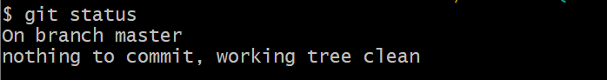
- Pull the remote repository
- Push all the pending changes, merges, and conflict resolutions from your local machine up to the remote repository
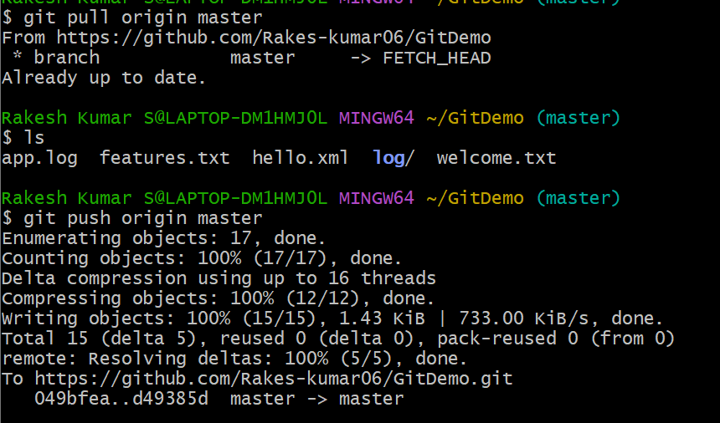

4. Observe that all the changes are reflected in the remote repository